A practical guide to help you with your technology scholarship or graduate role application.
ACS Foundation

SCHOLARSHIP application GUIDE

Table of Contents

Table of Contents 2
About Us 3
The IT Industry 4
Potential Careers in IT 5
Resume Advice 6
Cover Letter Advice 8
LinkedIn Profile Advice 10
Academic Transcripts & Results 12
Applying for a Role 13
Interview Tips and Technique 14
Frequently Asked Questions 16
Testimonials 18
Partners and Donors 19
Contact Us 21

3

About Us

The ACS Foundation was launched in 2001 to make the transition between high school/university to the tech workforce as easy as possible. Partnerships with universities and schools were formed, and since inception, we’ve helped students connect with almost 350 companies. As a result, we’ve processed over 20,000 applications and given out 6000+ scholarships, worth over $60 million. So when we give application advice, we’ve got experience backing us up.

Other things we’ve done include:
- Created student pathways from school to university to jobs.
- Integrated work and life experience with academic and university studies.
- Enhanced the future of the ICT Profession
- Established research grants and innovation building programs.

The IT Industry
$8,000,000,000
Predicted value of ICT industry in Australia
Source: John Ridge, ACSF

72%
Of new Australian IT workers have an Engineering, Maths, IT/Computer Science study background
Source: GradAustralia
By 2024, more Australians will be working in technology than living on Queensland’s Gold Coast
792,000
Australians will be employed in the technology sector by 2024
Source: ACS
4.2/5
Average rating of job satisfaction by technology graduates
Source: GradAustralia

Potential Careers in IT

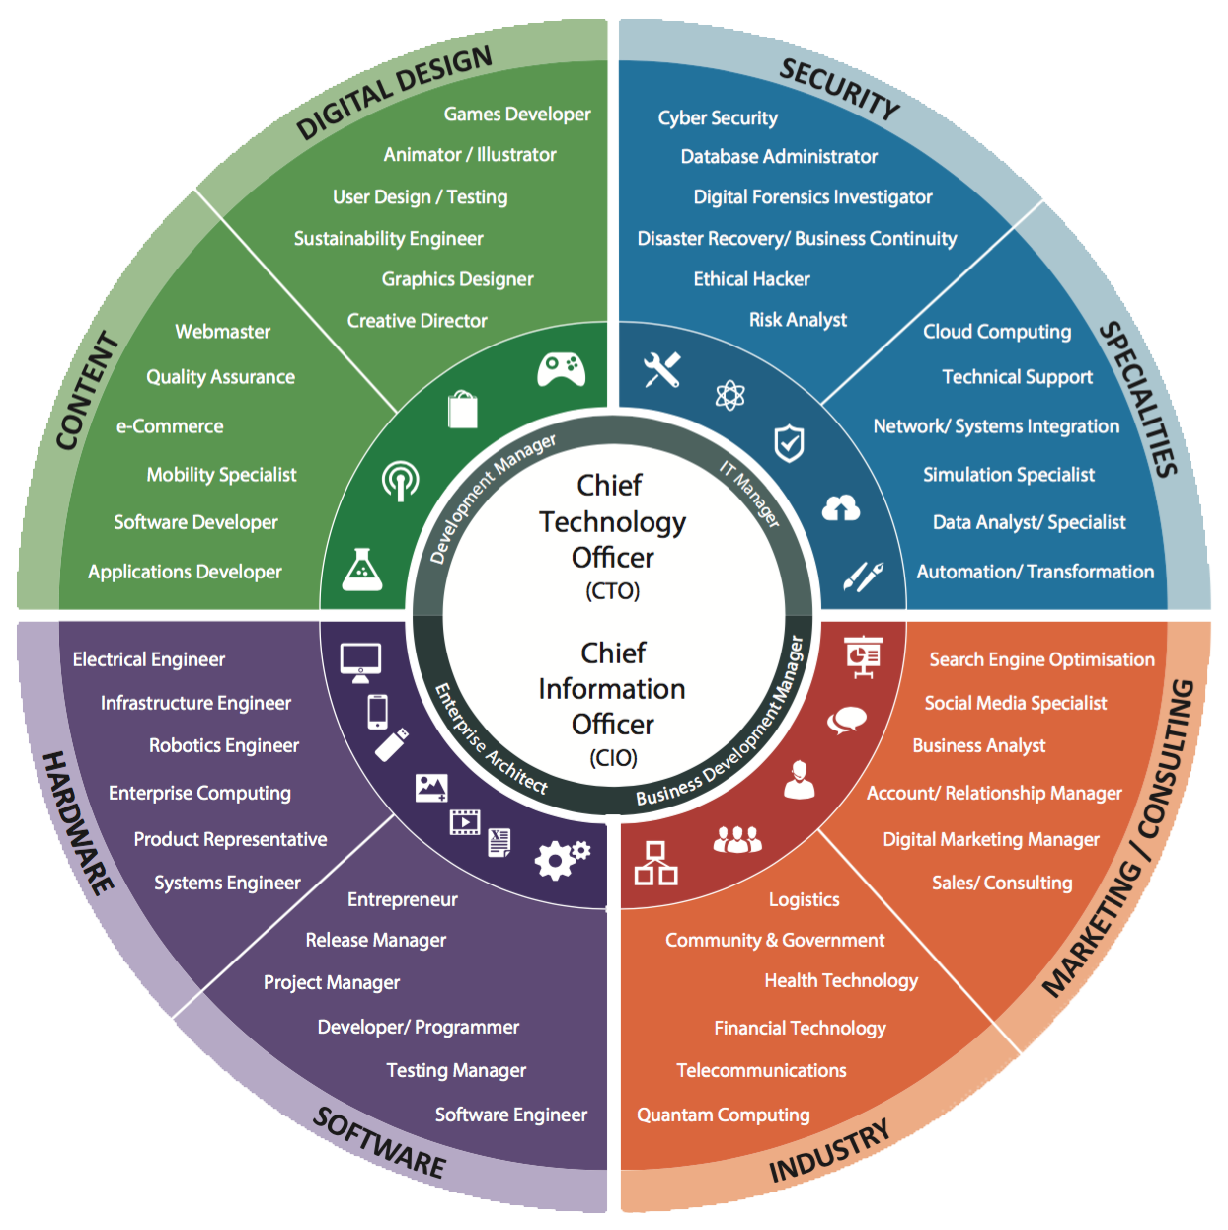
This is the ACS Foundation Career’s Wheel

To find out more, head to the interactive wheel at www.careersfoundation.com.au

Resume Advice
6

Your resume/CV needs to contain a few key things:
- Your Degree/Current Area of Study
- Relevant Work Experience
- Skills (especially for technical roles)
- Personal Details

These are the essentials. Three significant pieces of advice from here:

- How to stand out? Prospective employers are often looking evidence that you’re passionate about your area of study, and you’ve gone above and beyond to apply your knowledge. Workshops and projects are the best way to prove this.

- Traditional or Flamboyant design? While having a black and white text-filled document will not necessarily cause recruiters to discard your resume, having a colourful design may reflect you as a person better, and leave a more lasting impression. Use sites like resmue.io or Canva to come up with an appealing layout, but don’t make it too busy or difficult to read/look at.

- How to balance detail in an appropriate length? Make sure your resume avoids being overly lengthy. The best way to be concise but detailed is by using dot points and only talking about relevant experiences and skills. We recommend a resume of between 1-2 pages.

Basic Resume Template

<name>
<headline>
Address: <Address>
Date of Birth: <dob>
Email: <email>
Phone Number: <phone>

SUMMARY:
<One or two sentences about who you are, and your career goals/objectives>

EDUCATION:
For each qualification:
<Qualification Gained & Year Started/Finished>
<Institution>
- <Major>
- <WAM/Mark Average>
- <Relevant Courses relating to applied job>

RELVANT EXPERIENCES:
For each work experience (can include volunteering/less relevant experiences in a separate section):
<Position Title & Duration (Month/Year started and Finished)>
<Organisation/Company & City>
- <Summary of work activities, skills applied and major achievements in dot points>

SKILLS AND ATTRIBUTES:
List a few skills, especially for technical roles:
- <Skill, how you obtained it, and how you apply it>

8

Cover Letter Advice

Your cover letter needs to contain the following:
- An introduction of who you are
- Why you would suit the role on offer
- How your past experiences would allow you to perform in the role on offer

There are a few steps you should take when writing a cover letter to reach the above goals:

- Read the job description carefully. In every job description, especially for more technical roles, there are vital skills either listed explicitly or woven into the text. Find out what these critical skills are and take good note of the most important ones.

- Introduce yourself and your passions. Start your cover letter by making a bold introduction. Potential employers are also considering whether you will fit into their organisation and work culture, so be genuine and talk about your passions.

- Relate your experiences to necessary skills. In the first step, you identified the critical skills the role requires. Explain how you fulfil such requirements by integrating what you’ve learnt from your past experiences, whether they be in employment, education, co-curricular activities or volunteering.

Cover Letter Template

<<Date>>

Dear ACS Foundation/Sir/Madam,

Paragraph 1 – Internship/Scholarship position: Indicate the internship/scholarship position for which you are applying for (position, company) and show interest for the position

Paragraph 2 – Show research and interest of organisation: Indicate and explain why you are interested and a good fit for the internship/scholarship position in the organisation. Avoid quoting from the website and show understanding through your research in areas such as company’s organisational values, strategic direction and work culture. Researching recent articles or other valid sources that the organisation has been involved is good as well

Paragraph 3 – Address the Criteria: Spend some time outlining why you would be the right candidate for the position advertised based on the implicit and explicit criteria set out in the job description. Address the key criteria first, but for less essential criteria, just acknowledging and fulfilling them will be enough.

Paragraph 4 – Employment, work experience, volunteering or extra-curricular activities: Briefly highlighting the primary skills you have gained and would like to transfer into the internship/scholarship position and any relevant personal qualities and attributes. Refer to your work experience and other activities gained and back it up with examples as evidence.

Paragraph 5 – Availability: Indicate your availability and commitment concerning the internship/scholarship role. Such as if you’re able to work full time or which days you would be available if successful in the internship/scholarship position.

Paragraph 6 – Thank you: Thank the organisation/person for their time and consideration of your application. Advise on your availability for an interview.

Sincerely/Yours faithfully,

<<Your name>>
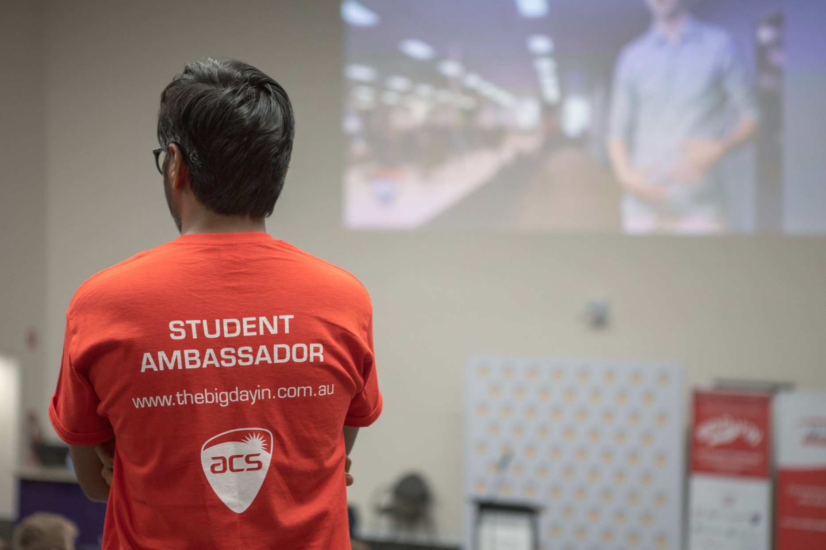
10

LinkedIn Profile Advice

Why is LinkedIn important?
LinkedIn is a professional networking social medium. It offers a professional way to present yourself to the world while allowing you to interact with a wide array of other professionals within and beyond the bounds of your industry. LinkedIn also opens many networking opportunities, which may lead you to your next internship or even a full-time job. This networking is especially relevant in the technology sector, where most employees only hire via word of mouth.

Steps to networking on LinkedIn:

Step 1: Establishing yourself
Establishing yourself means you need to have a complete profile, hence increasing the chance of others being interested in you:
- Profile Pic must be professional and feature only you (make sure the photo isn’t too staged, though)
- Have a good headline which speaks for you (avoid putting your current role, rather be as creative and open as possible with the 120-character limit)
- Treat your summary as an elevator pitch: Write in 1st person, describe yourself and describe what you can offer others.
- Recommendations are an essential way of adding credibility to your profile. Write some recommendations to others, and they’ll feel inclined to help you back.

Step 2: Choosing your networking style
There are two leading networking styles: Linked-in Open Networking, and Trusted Partner Networking.
Trusted Partner Networking involves:
- Only add the people you know/have done business with
- Keep in touch with your colleagues and existing business circle
- Maintain existing connections and infrequently discussing career matters
LinkedIn Open Networking involves:
- Actively adding different people to increase the size of their network
- Engages with the broader LinkedIn community and posts frequently
- Sends messages and sets up meetings with likeminded people

There is no right or wrong approach to networking on LinkedIn – it is up to you to decide which style you prefer; most users go for a mix of both.

Step 3: Networking
The most crucial step in the process – reaching out to others! Here’s what you SHOULD be doing when networking:
- Status Updates of how your current role is going, where your career is progressing
- Watching and interacting with the status updates of others
- Messaging likeminded people to have a chat about different ideas relating to an industry
Here’s what you SHOULD NOT be doing when networking:
- Oversharing or sharing unprofessional content
- Sharing confidential information about the internal workings of an organisation (contact your organisation’s HR/Legal department if you are unsure about a post)
- Harass others in messages, making demands or being rude in the private messaging format

Don’t forget to follow us on LinkedIn here: https://www.linkedin.com/company/acsfoundation/

Academic Transcripts & Results

You may be asked to provide your Academic details, including your transcript or equivalent. This is particularly relevant for internship roles, where there are minimal other ways to assess your competency.

Depending on which university you attend, you may not receive a copy of your official academic transcript until you graduate. However, you’ll be able to generate a copy of your academic record before graduating through your online portal. For most internship roles, these are acceptable to submit in place of a transcript. If you’re unsure, check with the organisation/our team before submitting.

Specific organisations may ask for a minimum/recommended Average Mark, e.g. “applicants require a credit average minimum”. It is vital to look at your academic record at the end of each semester and calculate your WAM (Weighted Average Mark) if your university does not provide it to you. If your WAM is:
- 50% - 64%, you have a PASS average
- 65% - 74%, you have a CREDIT average
- 75% - 84%, you have a DISTINCTION average
- 85% and above, you have a HIGH DISTINCTION average
Sample Academic Record
The hypothetical sample below contains the minimum information required when submitting an academic record. With a 76 WAM, this student has a D average.
Bachelor of Software Engineering (Record for Sample Student – 12345678)
Subject No. | Subject Name | Session | Grade | Mark
12345 | Beginners Programming | 2020 – Autumn | D | 81
54321 | Pure Maths 1 | 2020 – Autumn | C | 68
78945 | Website Development | 2020 – Autumn | D | 75
67890 | Web Architectures | 2020 – Autumn | HD | 91
96325 | Advanced Programming | 2020 – Spring | P | 52
58741 | Networking for Mobile | 2020 – Spring | D | 79
14785 | Cloud Computing 1 | 2020 – Spring | HD | 88

Applying for a Role

Once you have a resume, a cover letter draft, a strong LinkedIn profile and an academic transcript, you’re ready to apply for an ACS Foundation or Foundation Jobs role. The process is similar for both sites, which is neatly summarised in the following video:
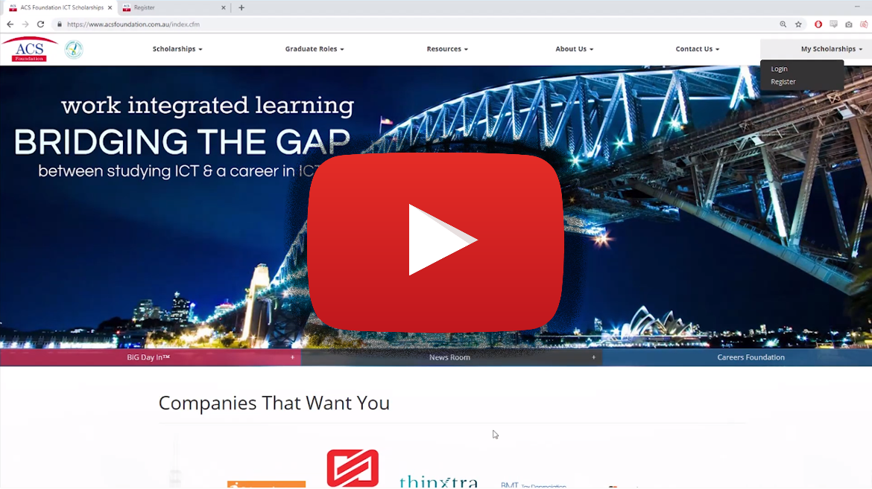

The website featured in the video is www.acsfoundation.com.au.
If you’re successful in passing the initial application stage, the host company will invite you to a phone or in-person interview.

Interview Tips and Technique
14

If an organisation is interested in you, you are likely, to begin with, a phone interview. This will generally take around 15 minutes, and you should try to find a quiet place where you can take the call and be very focussed on it. It would be best if you prepared for this call by checking their website and finding out as much information as you can about the company.

They are looking for people who can communicate well, who are enthusiastic about the concept of working for them, who are passionate and excited about IT. Besides, they want students/graduates who are generally sensible people and have the potential to be future employees.

If you are invited to attend an interview, then please make sure you are there at least 15 minutes before the time set for the interview. If you are not sure exactly where to go, then allow an extra 15-30 minutes. If you are going to be late, then please ring them in plenty of time and let them know.

You should try to prepare around 3 to 6 sensible questions to ask them about the role or the company - one of which should NOT be “how much money will I get paid?” Some of your questions will likely be answered by the interviewer during the interview, so you shouldn’t need to ask more than three questions.

In the interview one of the most important things they will be looking for is good communication skills. The interviewers don’t want “yes” or “no” answers – they are looking for a conversation. Don’t make it difficult extracting information from you - remember that they are looking to evaluate not just your technical capabilities, but also your presentation skills.

Practice before any interview is essential. The following process will help you prepare for an interview as best as possible:
- Make sure you know what questions the interviewer might ask (e.g. If you’re going for a software developer role, you’re going to be asked about what languages you know and what projects you’ve done)
- Make a list of sample questions which are relevant for the role you are applying.
- Ask yourself these questions and provide a realistic answer in the mirror, recording on your phone/through a webcam, or even in front of friends and family.
- Repeat this process, making sure you sound enthusiastic, confident and friendly in your responses.

Some questions, especially those about your behaviour and past experiences, may be answered merely using the STAR method, which stands for: Situation, Task, Action and Result. This method involves outlining a situation, explaining your task/role within that situation, outlining what action you had to take and what happened as a result.

Some sample questions are as follows:
- Tell me about yourself
- What do you know about this company?
- Why are you applying for this job? Why do you want this job?
- Describe a situation when you were under pressure
- What’s your biggest weakness?
- Where do you see yourself in five years?
- Why do you want to work here?
- What accomplishments are you most proud of?
- Tell me about a time you experienced failure and how you handled it.
- Describe a situation where you had to show leadership.
- What do you like to do outside work?
- Describe a time when you have worked as part of a successful team. What do you think contributed to your team’s overall success?
- Tell us about a goal that you have set yourself and worked towards, of which you feel truly proud or satisfied. What did you learn about yourself?

Frequently Asked Questions

Are there roles open for international students?
- Yes, there are numerous roles which are open to international students, alongside domestic students. Read through the other relevant questions to find out more about visa requirements for international students or contact us if you’re unsure about your eligibility.

How can I get more experience?
- If you have an idea of the industry you want to work in or even gain experience in, try looking at online internships. A lot of big firms offer online internships which you can complete at your own pace. Careerhub, Seek, Indeed, Foundation Jobs and ACS Foundation all have open internships and graduate roles as well.
What paperwork is required for a foundation scholarship application?
- There are mainly 4 pieces of paperwork required for each application you submit. Three of these pieces remain relatively consistent between applications, with the first piece: your cover letter, needing to match the requirements of every role you apply for. The remaining pieces are:
  - Your Resume (may change slightly for each application, pending on scope)
  - Academic Transcript (may change depending on release of university results)
  - Proof of Residency (either a passport, birth certificate, citizenship certificate or visa documents)

Will I need referees for my scholarship/foundation jobs application?
- The referee requirements vary from role to role, but typically the first stage of your application will not require referees. Following the early stages, if you’ve been successful and we progress your application, we will reveal the referee requirements to you. Anyone who isn’t related to you by blood may be an eligible referee, and you will be required to provide us with their name, position/capacity by which they know you and contact number.

Can companies sponsor my 485/Skilled Visa?
- Typically for work-integrated learning or graduate roles, visa sponsorship is difficult and unlikely. While it is not impossible, most organisations offering such programs find local talent sufficient to fill their positions, and as a result, don’t feel obliged to help with visa sponsorship.

Am I able to get a graduate role after my internship?
- Yes, your host organisation may offer you a graduate role if you’re in an internship (especially if you’re towards the end of your degree), or if you’re in a Foundation Jobs graduate role (offered a full-time position) after your placement. 79% of Scholarship recipients receive a graduate offer with their host organisation, so all you need to do is impress your host to put yourself in the running for a position.

How can I practice for online aptitude tests?
- Online psychometric tests are slightly harder to prepare for because most firms have different tests. Usually, the online psychometric tests are split into numerical and verbal sections which you must complete within a specific timeframe. Some people find that they don’t need to practice at all but if you are leaning towards getting some practice before doing a real one, consider having a look at these websites:
  - Psychometric Institute
  - Practice Reasoning Tests
  - Job Test Prep
  - Grad Australia Tips for Psychometric Testing
- Once you get into the test, divide your time carefully and don’t spend too much time on one question. Usually, the assessments are unfinishable, so don’t fret if you can’t get through all the questions in the allotted time. The best way to become more comfortable doing the tests is to practice!

Testimonials

“Hi, I’m Roneth Jaro and through the ACS Foundation I was given the opportunity to work in IBM for 6 months. During this time I was allocated to the Qantas Marlin Project which I performed the role of a Performance Test Analyst intern. In this placement, I learnt a lot about the Airline industry and the soft skills required to be a great consultant. In retrospective, I’m very thankful for the opportunity that ACS Foundation has given me as it has equipped me with the skills and knowledge that I can apply to further my professional career.”
Roneth Jaro, IBM

“I felt that there was reduced pressure placed on me as I was only a scholarship student. I was able to see what work I would be doing should I pursue a career in development and I was given tasks that reinforced or furthered knowledge gained through uni. I am very happy that I was placed in BankWest as I worked closely with some great people, was given real project work and was hired straight out my scholarship!”
Mitchell Henson, BankWest

“My experience with ACS Foundation has been so amazing. They are really prompt in replying and putting you on the right track. ACS Foundation helped me get a job at a position I was interested in. They have been really professional and accountable. Would highly recommend ACSF to all the job seekers. Thank you, ACS foundation!”
Devneet Singh Virdi, Hardcat

“My experience working with the Australian Computer Society Foundation as a Web Developer and IT support intern has provided me with invaluable skills which I continue to use both in my personal and professional life. I was able to extend my knowledge in programming that I learnt the fundamentals of in university, by completing task in a practical environment. Would highly recommend ACS Foundation for students looking for work experience in the IT industry.”
Calvin Nguyen, ACS Foundation

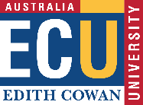
Partner Universities

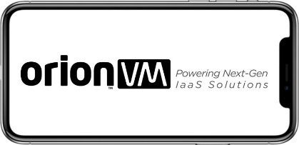
Some of our many donors…
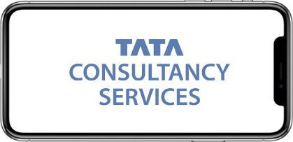

Phone: 02 8296 7700
Email: info@acsfoundation.com.au
Address: Level 1, 160 Clarence Street, Sydney NSW 2000

Follow us on social media:

Contact Us

